INVENTORY OF TOOL COMPONENTS

1. REXX Code

- LISTEXTS – Rexx program that creates the DB2 Dataset Extents Master File and the
Exceptions Summary Report. It is run in the DBLssid job.

- DMETRICS – Rexx program that creates the Metrics Totals Summary Report. It is run in the
DBMcust job.

- DCONNECT – Rexx program that does a simple DB2 Catalog query to test the DB2 to Rexx interface for a DB2 subsystem. It is run in the DCONssid job.

2. EJCL

- VCATssid – This job is run once for each DB2 subsystem during the 1st time setup of this tool. It does a query on the DB2 Catalog producing a list of all VCAT entries found in that DB2 subsystem. The information will be used to setup the LISTCAT Step in the DBLssid job.

- DCONssid – This job is run once for each DB2 subsystem during the 1st time setup of this tool. It does a simple DB2 Catalog query using the DB2 to Rexx interface to make sure it is
active and working correctly for that DB2 subsystem. It is run during the testing phase in the setup procedures before the DBLssid job is run for the 1st time.

c) DBLssid – This job is run monthly. One job is run for each DB2 subsystem. It collects, analyzes, and reports on LISTCAT information of all selected DB2 Linear datasets pulled from a
pre-defined list of DB2 VCAT High Level Qualifier (HLQ) patterns setup specifically for this job. It creates two output datasets, the DB2 Dataset Extents Master File and the Exceptions Summary Report. The DB2 Dataset Extents Master File is sent to the DBMcust job for further summarization used to create the monthly Metrics reporting statistics.

d) DBMcust – This job runs once monthly for each Customer (Account). It summarizes the
DB2 Dataset Extents Master Files collected from all DB2 subsystems for that
Customer (Account) and is run in one master location. It creates the Metrics Totals Summary Report which holds all the required monthly Metrics data summarized into one report for each Customer (Account) for monthly Metrics reporting.

NOTES______________________________________________________

- All components will be sent to you in an EMAIL as *.txt attachments.
- Updates may come in periodically. Use the same procedures to load the updates that you used in your initial setup of the tool.

STEP 1: INSTALL TOOL SOFTWARE COMPONENTS FROM EMAIL TO YOUR PC

- Create 2 new folders on your “C” Drive as suggested below:

c:\My Documents\DB2 DASD METRICS TOOL\Version 2005-06-17

NOTE: Multiple releases of these components may be received throughout the year, organizing your in-coming ships into Version yyyy-mm-dd folders will help you to simplify your on-going software maintenance for this tool.

- Detach all ****.TXT attachments from your EMAIL into the Version 2005-06-17 folder on your ”C” Drive.

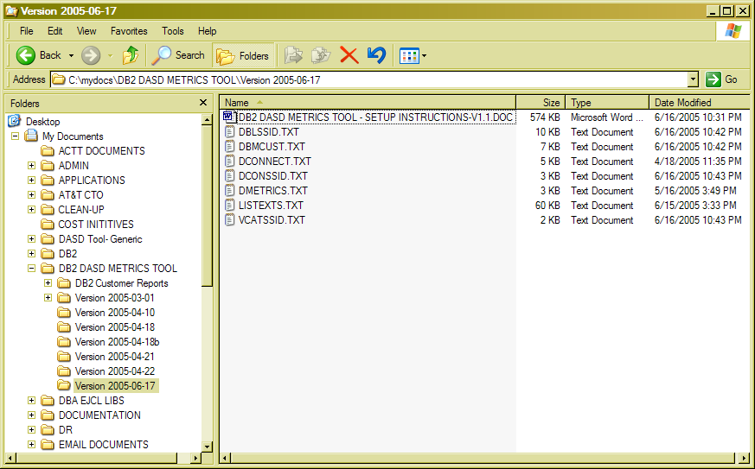

STEP 2: TRANSFER FILES FROM PC WORKSTATION TO MVS HOST

- Logon to your mainframe TSO session using the IBM Personal Communications 3270 emulator.

- Go to the TSO COMMAND PROCESSOR PANEL (ISPF 6).

Note: – Some systems may require the file transfer process to be toggled on and off with the “/F” command for 1st time use.

- In the IBM Personal Communications Window Toolbar, Click on the ACTIONS button.
A drop down box will appear (see below).

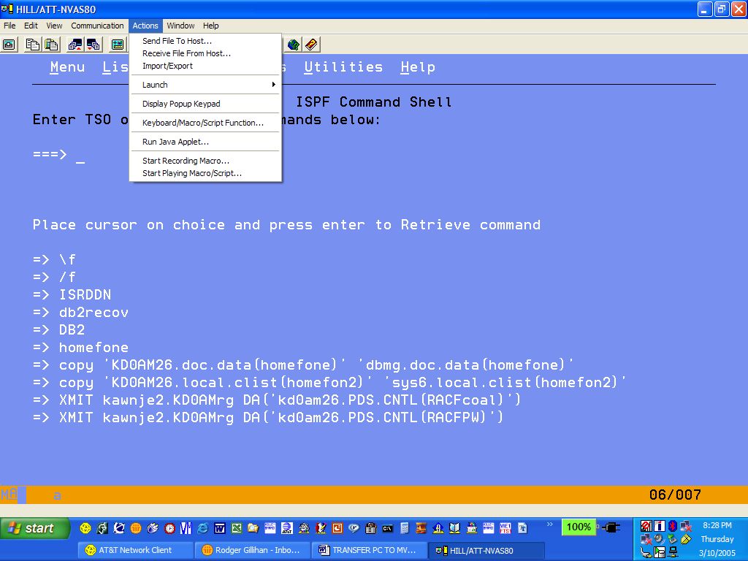

- Choose the “SEND FILE TO HOST” option. The following Pop-up box will appear:

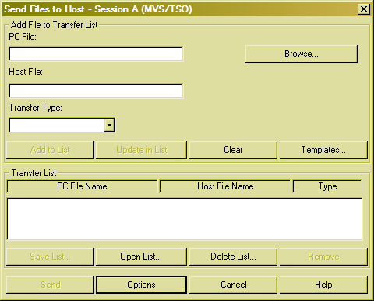

STEP 2: TRANSFER FILES FROM PC WORKSTATION TO MVS HOST (continued)

- If this is the 1st time transferring files with this Session Window, you will need to setup your File Transfer defaults.

a) Click on the OPTIONS button. A Pop-up window will appear (see 5c below)
b) Click on the GENERAL tab.
- Set Host Type to MVS/TSO.
- Set Packet Size to “8000”.
- Set File Transfer Timeout to at least 60 seconds.

c) Click on the MVS/TSO tab.
- Choose Transfer Type of “text”.
- Populate remaining fields as shown below:

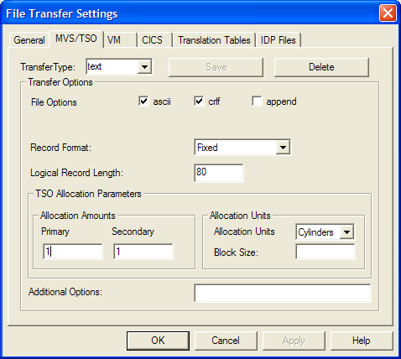

- Click SAVE, then APPLY, then OK.

d) Setup of File Transfer defaults is now complete.

STEP 2: TRANSFER FILES FROM PC WORKSTATION TO MVS HOST (continued)

- To setup the SEND FILE TO HOST Pop-up box – do the following:

  - To Populate the Transfer List box – fill in the following fields:

- PC File - Type in the full path name of file to be transferred from the PC Workstation or
Click BROWSE button. Drill down to find and select file on your PC Workstation to be transferred.
Format: ****.TXT
- Host File – Type in name of new MVS sequential dataset that will receive the **** .TXT file from the PC.
Format: ’hlq.****.TEXT’ NOTE: Your TSO ID will be used as default HLQ if quotes are not used.
- Transfer Type – Choose “text”.
- Click the Add to List button.

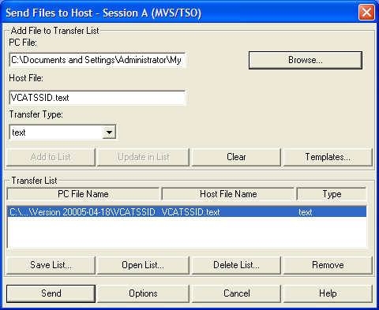

b) OPTIONAL: If you want to save this list for future use, Click the SAVE LIST button, fill in new name, Click SAVE.
c) Click SEND button.
d) Repeat Section 8a above until all 7 files have been transferred to this LPAR. File transfer is now complete.

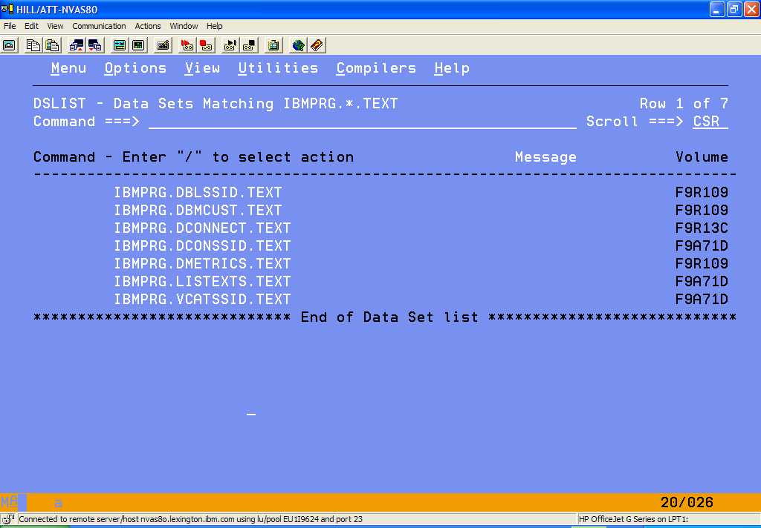

STEP 3: CREATE 3 NEW EJCL MEMBERS FOR EVERY DB2 SUBSYSTEM

Three new jobs will need to be created for every DB2 subsystem in each Customer (Account). The instructions below are to create one set of jobs for one DB2 subsystem. Please repeat this set of instructions for each DB2 subsystem to create all jobs needed to setup this process for each Customer (Account).

NOTE: You can choose to customize your new EJCL members from your PC Workstation or from the MVS host. The following instructions in this document will assist you in customizing the EJCL from the MVS host.

- Create 3 new members in your DBA EJCL PDS Library for this DB2 subsystem. Copy the contents of the EJCL templates (Sequential Datasets) you transferred to this LPAR into these 3 new PDS members as shown below.
NOTE: Populate your new member names with the actual “ssid” value for this DB2 subsystem.

a) VCATssid.TEXT -> DBA EJCL PDS Library (VCAT????)
b) DCONssid.TEXT -> DBA EJCL PDS Library (DCON????)
c) DBLssid.TEXT -> DBA EJCL PDS Library (DBL????)

- Create 2 new members in your DBA REXX PDS Library for this LPAR. (Be sure Rexx Lib is FB 80.) Copy the contents of the three Rexx Source Sequential Datasets you transferred to this LPAR into these 2 new PDS members.

a) LISTEXTS.TEXT -> DBA REXX PDS Library (LISTEXTS)
b) DCONNECT.TEXT -> DBA REXX PDS Library (DCONNECT)

- Change all temporary symbolics (all in lower case) located in the 3 new EJCL members with the actual values for this DB2 subsystem. The Symbolics Table below has been provided to help identify all fields that need to be customized in each EJCL member for each DB2 subsystem.

EJCL SYMBOLIC (lower case) | DESCRIPTION | JOBNAME
EJCL SYMBOLIC (lower case) | DESCRIPTION | VCATssid | DCONssid | DBLssid
-jobcard info here- | Standard DBA Jobcard for this Customer (Account) | x | x | x
-ssid- | DB2 subsystem | x | x | x
-cust- | Name of Customer (Account) |  |  | x
-lpar- | Machine name |  |  | x
-hlq- | Local High Level Qualifier |  |  | x
-rexxlib- | Rexx Source Library |  | x | x
-db2pgmlib- | DB2 Program Library | x | x | x
-vcat#- (# -> 1,2,3, etc.) | VSAM HLQ used for DB2 Datasets (see STEP 3 - #4 below) |  |  | x
-isp?lib-  (p,m,s,t) | ISP Libraries (see STEP 3 - #5 below) |  |  | x
ln_mgr-2, serv_off, div, dept, envir_type | 5 new DBA DATA MINING fields (future data feeds to be sent in 2006) |  |  | x

STEP 3: CREATE 3 NEW EJCL MEMBERS FOR EVERY DB2 SUBSYSTEM (continued)

- Populate the in-stream control cards in job DBLssid using the instructions below.

a) SUBMIT the VCATssid job.

b) The output from this job provides a complete listing of all VCAT entries defined in this DB2 subsystem in the proper format needed for the LISTCAT step in the DBLssid job. Review the list and choose the VCAT entries you want included in your DBLssid job for final Metrics reporting and analysis.

- Sample Output Report of a successful job run on the P2KR DB2 subsystem.

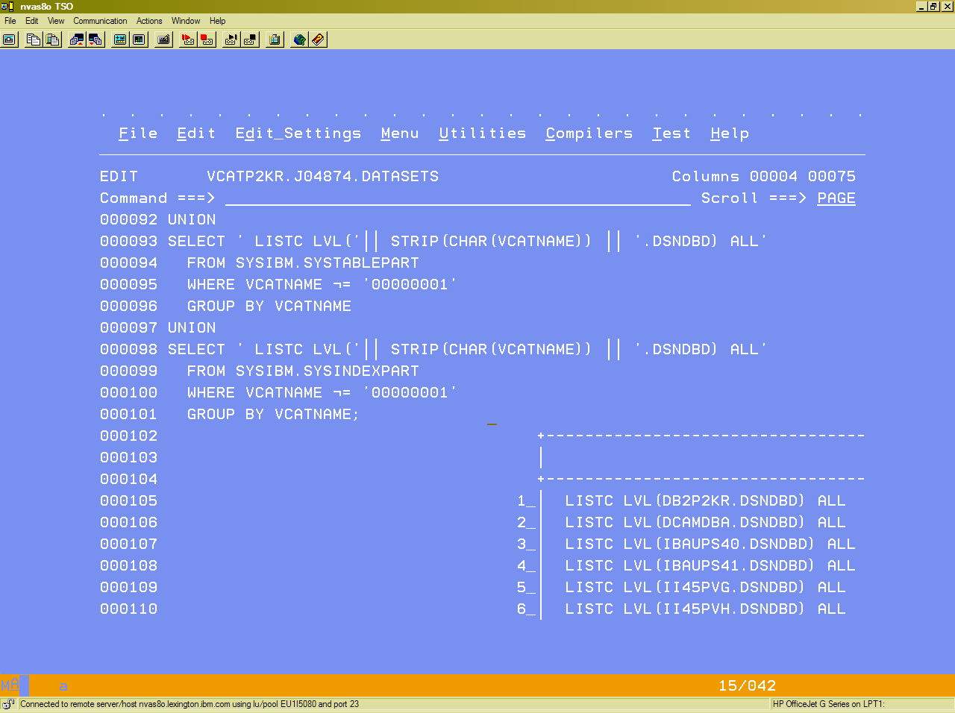

c) Populate the in-stream control cards in the following two locations:
- In STEP LISTCAT - populate the //SYSIN DD * as shown below:

//SYSIN DD *
NOTE: You can expand the DSN wildcard pattern down to 3rd or 4th qualifier to restrict the LISTCAT pull list to a lower level, if needed.
LISTC LVL(vcat1.DSNDBD) ALL
LISTC LVL(vcat2.DSNDBD) ALL
LISTC LVL(vcat3.DSNDBD) ALL
…
/*

- In STEP LISTEXT - populate the //INDB2SYS DD * as shown below:

//INDB2SYS DD *
-ssid-,-extlim-,-vcat1-
-ssid-,-extlim-,-vcat2-
-ssid-,-extlim-,-vcat3-
…
/*

STEP 3: CREATE 3 NEW EJCL MEMBERS FOR EVERY DB2 SUBSYSTEM (continued)

- Populate the four ISP Library DD’s (ISPPLIB, ISPMLIB, ISPSLIB and ISPTLIB) in job DBLssid using the instructions below.
a) Go to ISPF 6.
b) Type in ISRDDN. Hit ENTER.
c) A listing of all current Data set allocations for your TSO session will come up on the screen. Use this information to select the proper Library names that need to be populated in STEP LISTEXT for this LPAR where this DB2 subsystem resides.

d) One screen sample of part of the output that is received from the ISRDDN command is shown below.

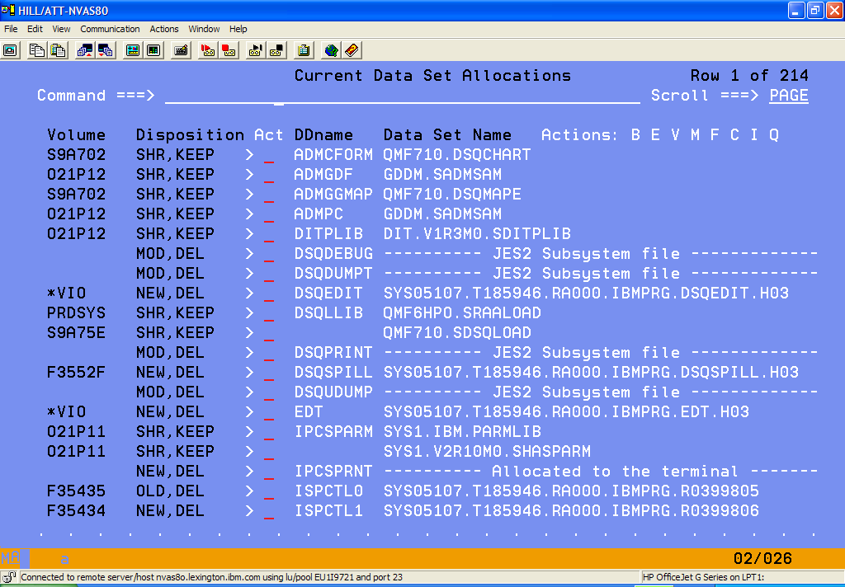

e) GENERAL HINTS:
- Choose the library names towards the bottom of the concatenation list for each DDname.
- All four ISP Library names that are needed will probably follow the same HLQ pattern.
- If in doubt, you can use all library names listed for the 4 ISP DDname’s that need to be populated.
- If you need additional assistance, contact your local MVS Support personnel.

STEP 4: CREATE ONE DBMcust JOB FOR EACH CUSTOMER (ACCOUNT)

One LPAR will need to be chosen as the master collection point of Metrics information for all DB2 subsystems for each Customer (Account). The instructions below are to create the DBMcust job on that chosen LPAR.

- Create 1 new member in your DBA EJCL PDS Library for this Customer (Account). Copy the contents of the DBMcust EJCL template (Sequential Dataset) you transferred to this LPAR into this new PDS member.
NOTE: Populate your new member name with the actual “cust” value for this Customer (Account).

a) DBMcust.TEXT -> DBA EJCL PDS Library (DBM????)

- Create 1 new member in your DBA REXX PDS Library for this LPAR. Copy the contents of the Rexx Source Sequential Dataset you transferred to this LPAR into this new PDS member.
a) DMETRICS.TEXT -> DBA REXX PDS Library (DMETRICS)

- Change all temporary symbolics (all in lower case) in this new EJCL member with the actual values for this
Customer (Account). The Symbolics Table below provides an inventory of all information that has to be customized in this job for each Customer (Account).

JOBNAME: DBMcust
EJCL SYMBOLIC (lower case) | DESCRIPTION
-jobcard info here- | Standard DBA Jobcard for this Customer (Account)
-cust- | Name of Customer (Account)
-ssid- | DB2 subsystem
-hlq- | Local High Level Qualifier
-lpar- | Machine name
-rpttitle- | Your Report Title for the Metrics Summary Report
-rexxlib- | Rexx Source Library

- Concatenate all output files collected from each DBLssid job for this Customer (Account) in the
// SORTIN DD found in the SORTINPT STEP .

STEP 5: TEST THE DB2 TO REXX CONNECTIVITY FOR EACH SUBSYSTEM (OPTIONAL)

- NOTE: This job only needs to be run if you are having DB2 connection problems in the DBLssid job.

- Submit the DCONssid job. This job will do a simple query on the DB2 Catalog to test the Rexx to DB2 interface on this DB2 subsystem.

- Here is a Sample Output Report of a successful job run on the P2KR DB2 subsystem.

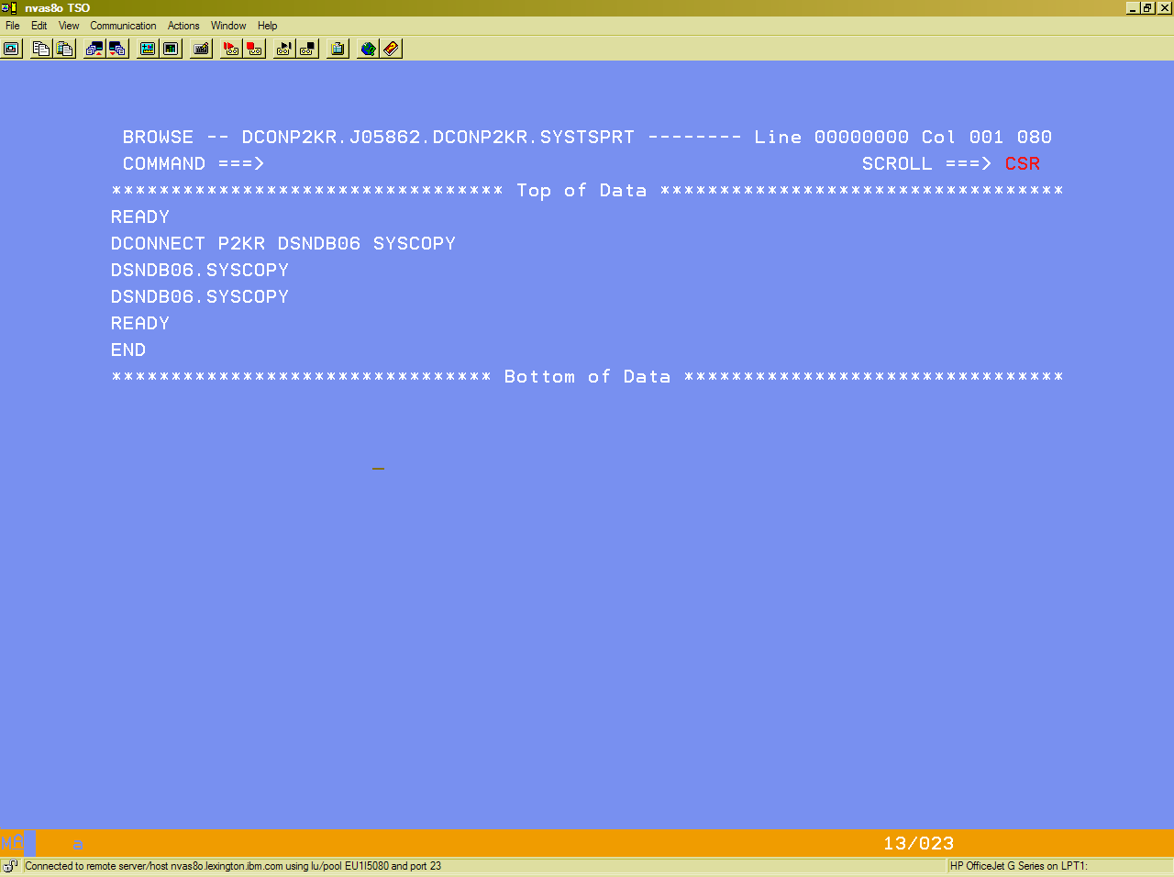

- If this job was not successful, work with your DB2 Systems Support personnel to identify and fix all problems until a successful test run is achieved

HINT: You need the DSNREXX plan bound on your DB2 subsystem for this interface to work. This interface is included in the standard DB2 V7 base install package. If you are on DB2 V6, a PTF is available to add this function.

STEP 6: PERFORM 1st RUN OF NEW METRICS COLLECTION JOBS

- Select one DB2 subsystem to be used as your 1st time run location.

- Submit the DBLssid job for that DB2 subsystem.

- Override the DBMcust EJCL (STEP SORTINPT) to take in only one SORTIN file just created from the DBLssid job above.

- Submit the DBMcust job.

- Below is a Sample of the Metrics Totals Summary Report taken from the Hillenbrand Account (DBMHILL).

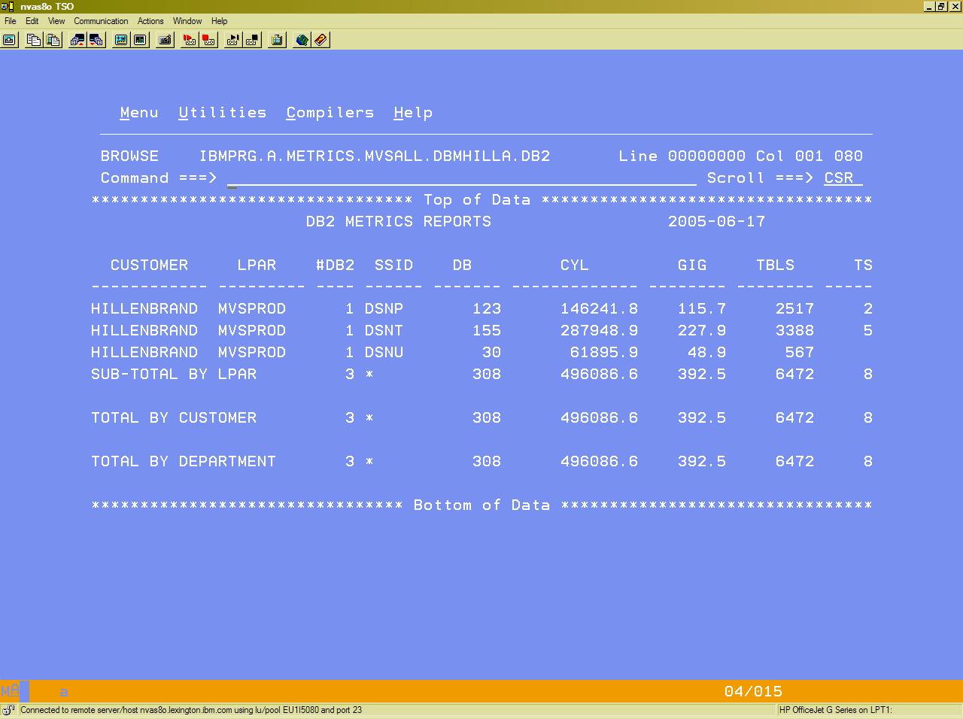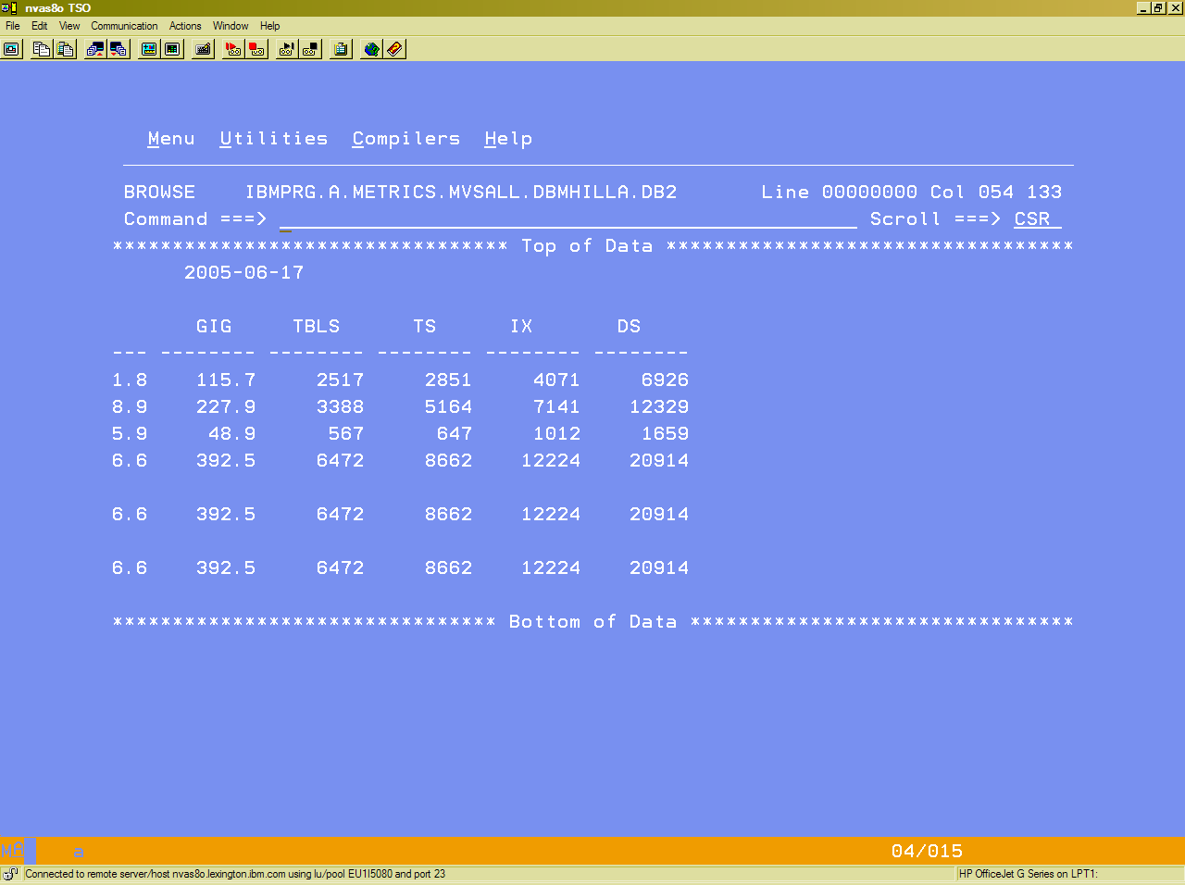

STEP 7: INSTALLATION OF NEW DB2 DASD METRICS TOOL JOB FLOW

After all EJCL has been successfully tested, all the DB2 DASD METRICS TOOL jobs can now to be setup as an automated monthly process.

- Sample monthly Job Flow for each Customer (Account)

DBLssid1 DBLssid2 DBLssid3 DBLssid4 DBLssid5

DBMcust

NOTE: If your DBLssid outputs are created on different LPAR’s, you will need to add a transmit process to move them all to one common
LPAR where the DBMcust will be run.

